**Mapping Volume**

Create a user case where:

- Create a docker volume: codemind_volume.

- Map it within container name: codemind_container1 to a location: /opt/log/.

- Get some data generated [touch [1..3].txt] inside container on location: /opt/log/.

- Validate this data is getting copied in docker volume host's path.

- Remove container name: codemind_container1.

- Run a new container name: codemind_container1 with mapping of volume: codemind_volume.

- Test and validate that data from previous container is getting reflected in the new container via this volume mapping

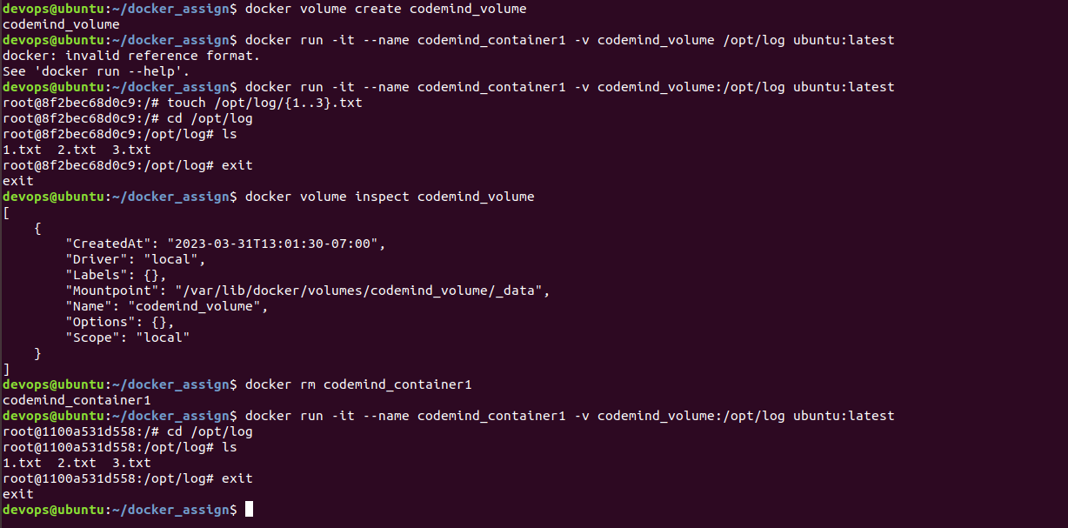

Step 1: Create docker volume: Codemind_volume



Step 2: Map it within container Codemind_container1 at location /opt/log. Create few files inside the location: touch{1..3}.txt. Inspect about the Volume using ‘docker volume inspect’ cmd.

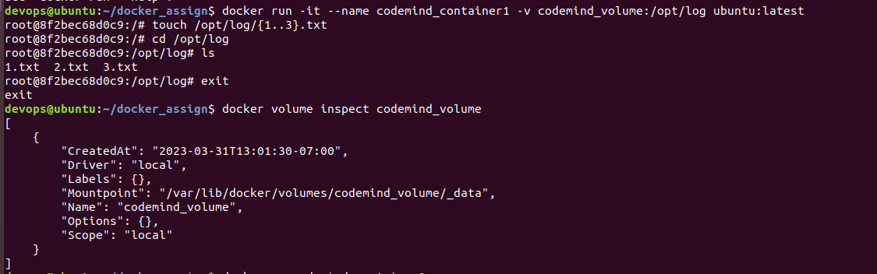

Step 4: Now remove the container: Codemind_container1



Step 5: Now run a new container with name: Codemind_container1 with mapping of codemind_volume. Test and validate that data from previous container is getting reflected in the new container via this volume mapping.

